Celia Ryder Partners Presents…

The Best of “Endworld”

A Showcase of Christopher Hoyle’s New Musical

Chris: Vocals & Accompaniment ♣ Gordon Engel: Percussion, Vocals

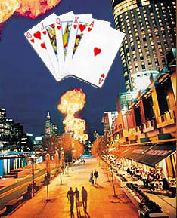
Two brothers open up a casino about the end of the world, and it's explosively successful…

- but will it blow apart their friendship?

At the Legendary
♦
CB 313 Gallery
313 Bowery, New York New York 10003
Questions, Call The Gallery at 212 677-0455 or Chris at 973 765-0063
Detailed Directions: http://www.cbgb.com/directions.htm

Sunday August 15, 2004 ♥ 8PM ♠ $5

(1-Drink Minimum)

Surf to ChristopherHoyle.com for More Info and MP3 Samples

