Celia Ryder Partners Presents…

The Best of “Endworld”

A Showcase of Christopher Hoyle’s New Musical

Chris: Vocals & Accompaniment ♣ Gordon Engel: Percussion, Vocals

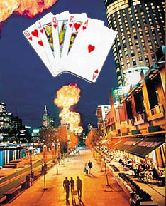
Two brothers open up a casino about the end of the world, and it's explosively successful…

- but will it blow apart their friendship?

At the Historic
♦
Darress Theater
615 Main Street, Boonton New Jersey 07005
Exit 44/45 Off I-287
For Reservations, Call the Darress Theater Box Office at
973-334-9292 or 973-334-9293
Detailed Directions: http://www.darresstheater.com/directions.html

Friday May 21, 2004 ♥ 8PM ♠ $7

Surf to ChristopherHoyle.com for More Info and MP3 Samples

